**CREATE EDIT DETAIL DELETE FUNCTION IN MVC**

**MODEL**

public class tbl_item_category

{

public int CategoryID { get; set; }

public string CategoryName { get; set; }

public string CategoryDesc { get; set; }

}

**ConnectionString**

public partial class TMEntities : DbContext

{

public TMEntities()

: base("name=TMEntities")

{

}

public virtual DbSet<tbl_item_category> tbl_item_category { get; set; }

}

DATAMADEL

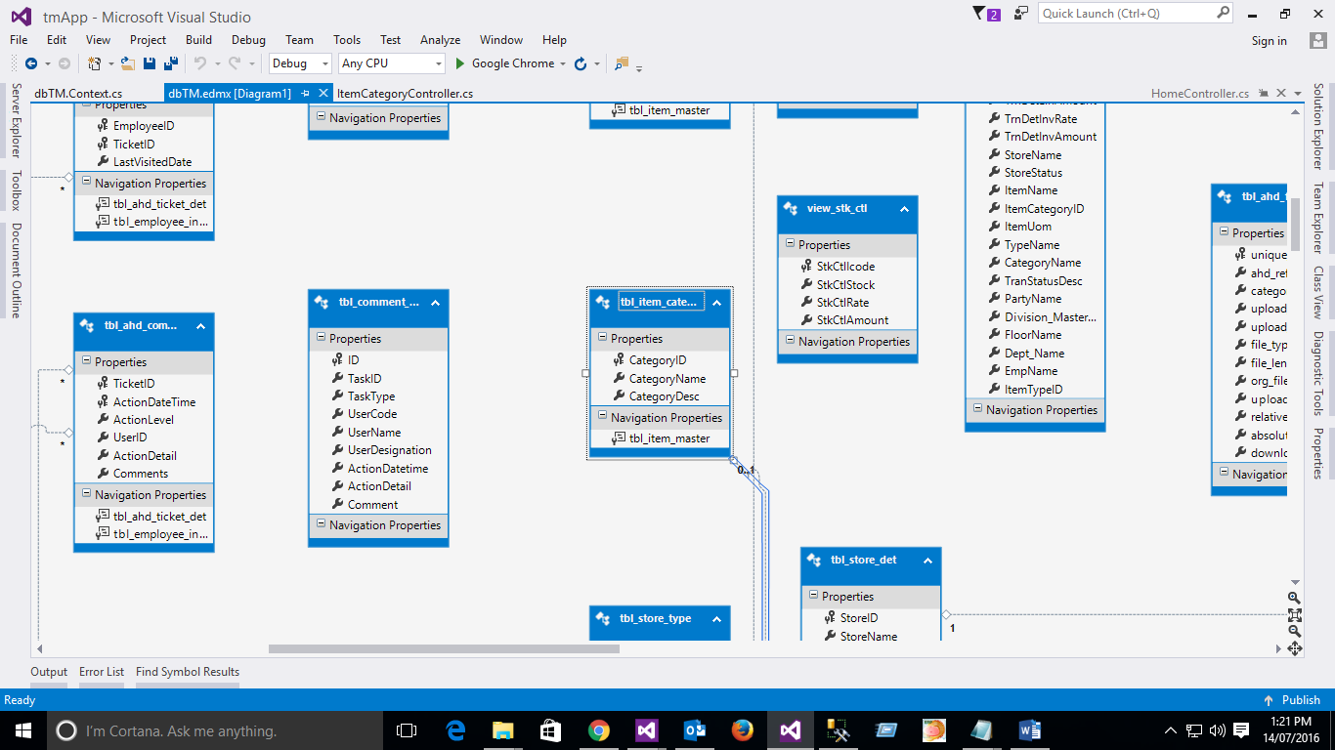

CONTROLLER

using System;

using System.Collections.Generic;

using System.Data;

using System.Data.Entity;

using System.Linq;

using System.Net;

using System.Web;

using System.Web.Mvc;

using tmApp.Models.TM;

namespace tmApp.Controllers.STORE

{

[CustomAuthorize]

public class ItemCategoryController : Controller

{

private TMEntities db = new TMEntities();

// GET: ItemCategory

public ActionResult Index()

{

return View(db.tbl_item_category.ToList());

}

// GET: ItemCategory/Details/5

public ActionResult Details(int? id)

{

if (id == null)

{

return new HttpStatusCodeResult(HttpStatusCode.BadRequest);

}

tbl_item_category tbl_item_category = db.tbl_item_category.Find(id);

if (tbl_item_category == null)

{

return HttpNotFound();

}

return View(tbl_item_category);

}

// GET: ItemCategory/Create

public ActionResult Create()

{

tbl_item_category article = new tbl_item_category();

try

{

article.CategoryID = db.tbl_item_category.Max(cat => cat.CategoryID) + 1;

}

catch

{

article.CategoryID = 1;

}

ViewData.Model = article;

return View();

}

[HttpPost]

[ValidateAntiForgeryToken]

public ActionResult Create([Bind(Include = "CategoryID,CategoryName,CategoryDesc")] tbl_item_category tbl_item_category)

{

if (ModelState.IsValid)

{

db.tbl_item_category.Add(tbl_item_category);

db.SaveChanges();

return RedirectToAction("Index");

}

return View(tbl_item_category);

}

// GET: ItemCategory/Edit/5

public ActionResult Edit(int? id)

{

if (id == null)

{

return new HttpStatusCodeResult(HttpStatusCode.BadRequest);

}

tbl_item_category tbl_item_category = db.tbl_item_category.Find(id);

if (tbl_item_category == null)

{

return HttpNotFound();

}

return View(tbl_item_category);

}

[HttpPost]

[ValidateAntiForgeryToken]

public ActionResult Edit([Bind(Include = "CategoryID,CategoryName,CategoryDesc")] tbl_item_category tbl_item_category)

{

if (ModelState.IsValid)

{

db.Entry(tbl_item_category).State = EntityState.Modified;

db.SaveChanges();

return RedirectToAction("Index");

}

return View(tbl_item_category);

}

// GET: ItemCategory/Delete/5

public ActionResult Delete(int? id)

{

if (id == null)

{

return new HttpStatusCodeResult(HttpStatusCode.BadRequest);

}

tbl_item_category tbl_item_category = db.tbl_item_category.Find(id);

if (tbl_item_category == null)

{

return HttpNotFound();

}

return View(tbl_item_category);

}

// POST: ItemCategory/Delete/5

[HttpPost, ActionName("Delete")]

[ValidateAntiForgeryToken]

public ActionResult DeleteConfirmed(int id)

{

tbl_item_category tbl_item_category = db.tbl_item_category.Find(id);

db.tbl_item_category.Remove(tbl_item_category);

db.SaveChanges();

return RedirectToAction("Index");

}

protected override void Dispose(bool disposing)

{

if (disposing)

{

db.Dispose();

}

base.Dispose(disposing);

}

}

}

**View**

**Index page**

@model IEnumerable<tmApp.Models.TM.tbl_item_category>

@{

ViewBag.Title = "Index";

}

<h2>Category List</h2>

<p>

@Html.ActionLink("Create New Category", "Create")

</p>

<table class="table">

<tr>

<th>

@Html.DisplayNameFor(model => model.CategoryID)

</th>

<th>

@Html.DisplayNameFor(model => model.CategoryName)

</th>

<th>

@Html.DisplayNameFor(model => model.CategoryDesc)

</th>

<th></th>

</tr>

@foreach (var item in Model) {

<tr>

<td>

@Html.DisplayFor(modelItem => item.CategoryID)

</td>

<td>

@Html.DisplayFor(modelItem => item.CategoryName)

</td>

<td>

@Html.DisplayFor(modelItem => item.CategoryDesc)

</td>

<td>

@Html.ActionLink("Edit", "Edit", new { id=item.CategoryID }) |

@Html.ActionLink("Details", "Details", new { id=item.CategoryID }) |

@Html.ActionLink("Delete", "Delete", new { id=item.CategoryID })

</td>

</tr>

}

</table>

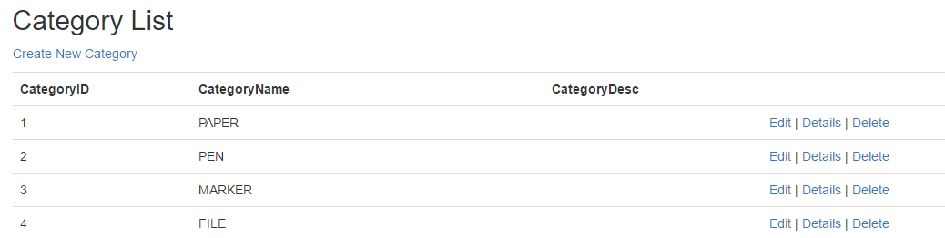

CREATE

@model tmApp.Models.TM.tbl_item_category

@{

ViewBag.Title = "Create";

}

<h2>Create Category</h2>

@using (Html.BeginForm())

{

@Html.AntiForgeryToken()

<div class="form-horizontal">

<hr />

@Html.ValidationSummary(true, "", new { @class = "text-danger" })

<div class="form-group">

@Html.LabelFor(model => model.CategoryID, htmlAttributes: new { @class = "control-label col-md-2" })

<div class="col-md-10">

@Html.EditorFor(model => model.CategoryID, new { htmlAttributes = new { @class = "form-control" } })

@Html.ValidationMessageFor(model => model.CategoryID, "", new { @class = "text-danger" })

</div>

</div>

<div class="form-group">

@Html.LabelFor(model => model.CategoryName, htmlAttributes: new { @class = "control-label col-md-2" })

<div class="col-md-10">

@Html.EditorFor(model => model.CategoryName, new { htmlAttributes = new { @class = "form-control" } })

@Html.ValidationMessageFor(model => model.CategoryName, "", new { @class = "text-danger" })

</div>

</div>

<div class="form-group">

@Html.LabelFor(model => model.CategoryDesc, htmlAttributes: new { @class = "control-label col-md-2" })

<div class="col-md-10">

@Html.EditorFor(model => model.CategoryDesc, new { htmlAttributes = new { @class = "form-control" } })

@Html.ValidationMessageFor(model => model.CategoryDesc, "", new { @class = "text-danger" })

</div>

</div>

<div class="form-group">

<div class="col-md-offset-2 col-md-10">

<input type="submit" value="Create" class="btn btn-default" />

</div>

</div>

</div>

}

<div>

@Html.ActionLink("Back to List", "Index")

</div>

@section Scripts {

@Scripts.Render("~/bundles/jqueryval")

}

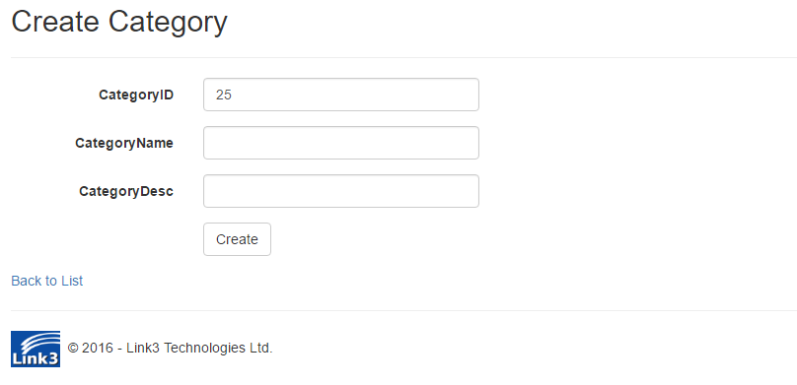

EDIT

@model tmApp.Models.TM.tbl_item_category

@{

ViewBag.Title = "Edit";

}

<h2>Edit Category</h2>

@using (Html.BeginForm())

{

@Html.AntiForgeryToken()

<div class="form-horizontal">

<hr />

@Html.ValidationSummary(true, "", new { @class = "text-danger" })

@Html.HiddenFor(model => model.CategoryID)

<div class="form-group">

@Html.LabelFor(model => model.CategoryID, htmlAttributes: new { @class = "control-label col-md-2" })

<div class="col-md-10">

@Html.DisplayFor(model => model.CategoryID, new { htmlAttributes = new { @class = "form-control" } })

</div>

</div>

<div class="form-group">

@Html.LabelFor(model => model.CategoryName, htmlAttributes: new { @class = "control-label col-md-2" })

<div class="col-md-10">

@Html.EditorFor(model => model.CategoryName, new { htmlAttributes = new { @class = "form-control" } })

@Html.ValidationMessageFor(model => model.CategoryName, "", new { @class = "text-danger" })

</div>

</div>

<div class="form-group">

@Html.LabelFor(model => model.CategoryDesc, htmlAttributes: new { @class = "control-label col-md-2" })

<div class="col-md-10">

@Html.EditorFor(model => model.CategoryDesc, new { htmlAttributes = new { @class = "form-control" } })

@Html.ValidationMessageFor(model => model.CategoryDesc, "", new { @class = "text-danger" })

</div>

</div>

<div class="form-group">

<div class="col-md-offset-2 col-md-10">

<input type="submit" value="Save" class="btn btn-default" />

</div>

</div>

</div>

}

<div>

@Html.ActionLink("Back to List", "Index")

</div>

@section Scripts {

@Scripts.Render("~/bundles/jqueryval")

}

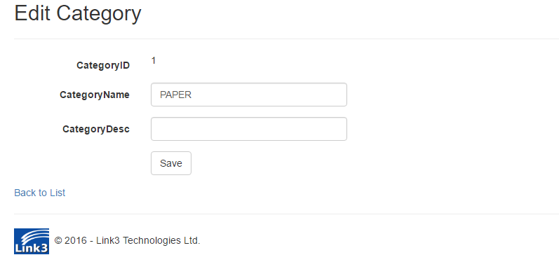

DETAIL

@model tmApp.Models.TM.tbl_item_category

@{

ViewBag.Title = "Details";

}

<h2>Details Category</h2>

<div>

<hr />

<dl class="dl-horizontal">

<dt>

@Html.DisplayNameFor(model => model.CategoryID)

</dt>

<dd>

@Html.DisplayFor(model => model.CategoryID)

</dd>

<dt>

@Html.DisplayNameFor(model => model.CategoryName)

</dt>

<dd>

@Html.DisplayFor(model => model.CategoryName)

</dd>

<dt>

@Html.DisplayNameFor(model => model.CategoryDesc)

</dt>

<dd>

@Html.DisplayFor(model => model.CategoryDesc)

</dd>

</dl>

</div>

<p>

@Html.ActionLink("Edit", "Edit", new { id = Model.CategoryID }) |

@Html.ActionLink("Back to List", "Index")

</p>



DELETE

@model tmApp.Models.TM.tbl_item_category

@{

ViewBag.Title = "Delete";

}

<h2>Delete Category</h2>

<h3>Are you sure you want to delete this?</h3>

<div>

<hr />

<dl class="dl-horizontal">

<dt>

@Html.DisplayNameFor(model => model.CategoryID)

</dt>

<dd>

@Html.DisplayFor(model => model.CategoryID)

</dd>

<dt>

@Html.DisplayNameFor(model => model.CategoryName)

</dt>

<dd>

@Html.DisplayFor(model => model.CategoryName)

</dd>

<dt>

@Html.DisplayNameFor(model => model.CategoryDesc)

</dt>

<dd>

@Html.DisplayFor(model => model.CategoryDesc)

</dd>

</dl>

@using (Html.BeginForm()) {

@Html.AntiForgeryToken()

<div class="form-actions no-color">

<input type="submit" value="Delete" class="btn btn-default" /> |

@Html.ActionLink("Back to List", "Index")

</div>

}

</div>

